https://www.jdoodle.com/embed/v0/5YcF
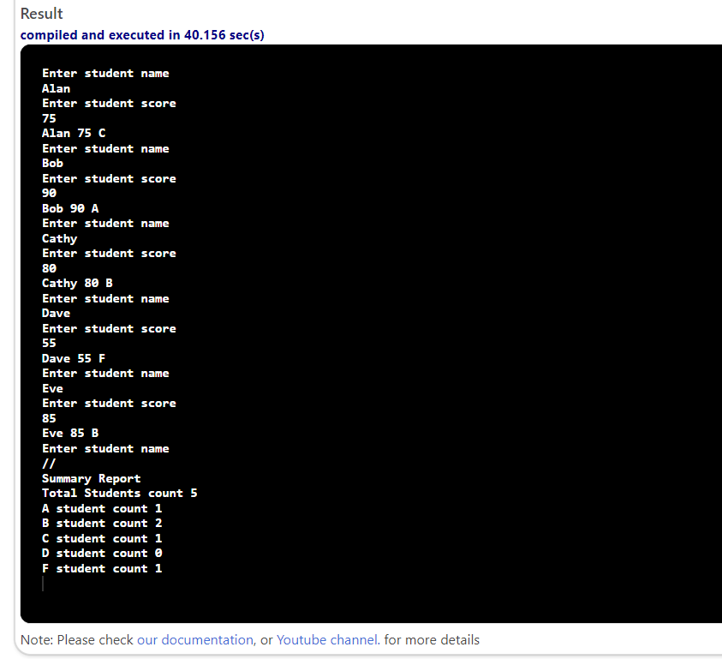

#include <iostream>
using namespace std;
int main()
{
char grade;
string name;
double score;
int aCount=0, bCount=0, cCount=0, dCount=0, fCount=0;
cout << "Enter student name" << endl;
cin >> name;
while (name != "//")
{
cout << "Enter student score" << endl;
cin >> score;
if (score>=90.0)
{
grade = 'A';
aCount++;
}
else if (score>=80.0)
{
grade = 'B';
bCount++;
}
else if (score>=70.0)
{
grade = 'C';
cCount++;
}
else if (score>=60.0)
{
grade = 'D';
dCount++;
}
else if (score<=60)
{
grade = 'F';
fCount++;
}
cout << name << " " << score << " " << grade << endl;
cout << "Enter student name" << endl;
cin >> name;
}
int totalCount=aCount+bCount+cCount+dCount+fCount;
cout << "Summary Report" << endl;
cout << "Total Students count " << totalCount << endl;
cout << "A student count " << aCount << endl;
cout << "B student count " << bCount << endl;
cout << "C student count " << cCount << endl;
cout << "D student count " << dCount << endl;
cout << "F student count " << fCount << endl;
return 0;
}

